CHAMELEONS NEWS
The monthly newsletter for the Cardiff Chameleons swimming & bowls club
Volume 29 / Issue 10 / October 2022
Affiliated to: MENCAP / Special Olympics Wales / Special Olympics GB /
Welsh Sports Association for people with Learning Disabilities

www.cardiffchameleons.co.uk Registered Charity Number 1103879


1926 2022
1926 2022

ANNUAL GENERAL MEETING
This is being held at Howells School at 7pm on Tuesday 18th October.
We will be wanting to elect a vice chairman; and we would also like to have some more committee members to help out at events that we put on during the year. If you are interested in either of these posts then contact me as soon as possible. If you have any comments on the club; please submit them to me if you cannot attend in person. Steve, my contact details are at the end of the newsletter.

ANNUAL MEMBERSHIP
Payment for this is usually each October. This is being deferred until after the AGM.
CONGRATULATIONS!
To Laura Knight, you’d never believe it, but Laura is celebrating her 40th birthday this month. We all hope you have a great day!

SWIM SESSIONS
You will need to book your place if you are attending for the first time, after that you will be put on the list that you will be attending regularly. However, if you are not going to attend at a session, please can you let Pamela know.
HOWELLS SCHOOL sessions for October are on Sunday 2nd, 9th, 16th, 23rd and the 30th.
There is now only one session and that is from 6.15pm to 7.00pm.

For our beginners, their session will be for a half hour from 5.45pm – 6.15pm.

CMCS&S Club - the sessions for October are on Thursday 6th, 13th, 20th and the 27th from 8pm until 8:45pm.

BRIDGEND SHARKS GALA
Well done to those who competed at this event last month. It was a good gala with most coming away with a medal.

BOWLS SESSIONS
This just a reminder as Barrie has probably informed most bowlers that the rink fee will now be £3.50 from 1st September.

COFFEE MORNING
Pamela is arranging for a coffee morning on Saturday 26th November at St. Philip Evans church hall, Llanedeyrn Drive, from 10am – 12 noon. Entry will be at £2.00 and you pay on the door. We hope to be selling Christmas wrapping paper and cards! The usual raffle and of course coffee / tea / hot chocolate by the mug full and mince pies and biscuits for those who don’t like mince pies! More details next month.

CHRISTMAS BUFFET & DISCO
Pamela has booked the Sports and Social Club at the Heath Hospital and we are opening this event to ALL members for our Christmas event this year.
The evening will consist of a buffet, bar, a strip raffle tickets for one special prize and the music provided by our usual DJ Nick Palmer.
All this at £10.00 per person and tickets will be on sale later this month!
The date for your diary, or whatever device you use to remind yourself with, is Thursday 15th December starting from 7.30pm. There will also be our normal raffle should you be unlucky not to win the special prize!

50+ CLUB
The lucky winners are:
July - £15.00 to Jane Ratcliff and £10.00 to Gareth Clark
August - £15.00 to Gabriel Pearson and £10.00 to Jill Bourne
September - £15.00 to Ann Minchin and £10.00 to Kristina Rees

MONEY FROM MENCAP
Wayne Crocker from MENCAP presented us with a cheque for £2,500.00 left from a legacy for MENCAP clubs in the south Wales area. 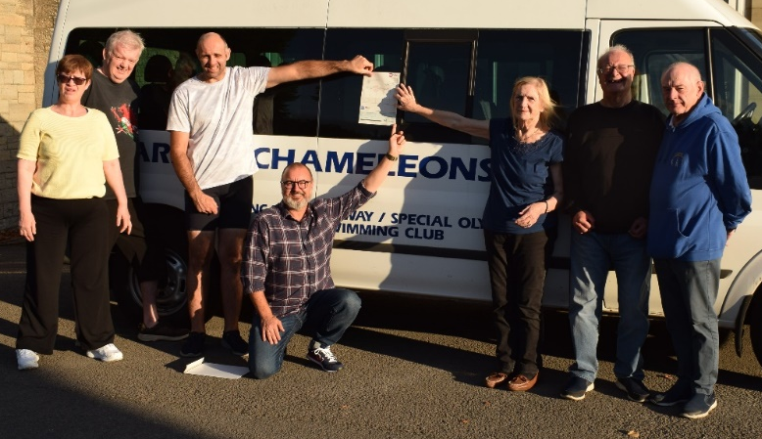
This may help us towards getting a new mini-bus in the future. Presented to us at our Howells swim session.L-R Julie Chinchen, Richard Marshall, James Savory, Wayne Crocker, Denise Pearson, John Stafford and Barrie Jenkins.
Photograph: Photography by Stephen Bailey

BANK TRANSFERS
To avoid paying bank charges on cash and cheques when paying any monies to the Club please try and do it by bank transfer, the details are…
Bank: HSBC – Account name – Cardiff Chameleons – Sort Code 40-16-30 Account Number 01431285
It would also be helpful if you could add your surname and reason for payment e.g. Membership.
Many thanks for your help.

How to contact us
Coaches | Pamela – 029 2025 7314 / 07817 380355 pamela.bailey6@virginmedia.com
Coaches | Robin – 029 2021 6008
Coaches | Barrie – 029 2075 3038 / barriejenkins50@live.com
Treasurer | Barrie Jenkins – Details as above.
Newsletter  &  Chair | Steve – 029 2025 7314 / 07791 759360 /stephen.bailey497@ntlworld.com  33 Ty Cerrig, Pentwyn, Cardiff. CF23 7DP  Items for the newsletter to be in 5 days prior to the end of the month. Please put it as a Word attachment if on e-mail
Other contacts | Denise – 029 2075 2909 Ian – 029 2023 3065
Club sessions
Swimming - Howells School – Sunday 5.45 – 6.15pm (novices) and 6.15 – 7.00pm (First time booking required)
Cardiff Medical Centre Sports & Social Club (UHW site) – Thursday 8.00pm – 8.45pm (First time booking required)
Bowls – Cardiff Indoor Bowls Club - Friday 4.00 – 6.00pm

