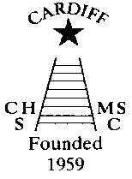
CHAMELEONS NEWS
The monthly newsletter for the Cardiff Chameleons swimming & bowls club
Volume 30/ Issue 1 / January 2023
Affiliated to: MENCAP / Special Olympics Wales / Special Olympics GB /
Welsh Sports Association for people with Learning Disabilities

www.cardiffchameleons.co.uk Registered Charity Number 1103879

HAPPY NEW YEAR!
I hope you all had a great Christmas and a wonderful new year and looking forward to restarting your bowls and swimming sessions and attending this year’s events both sporting and social.

CHRISTMAS BUFFET & DISCO
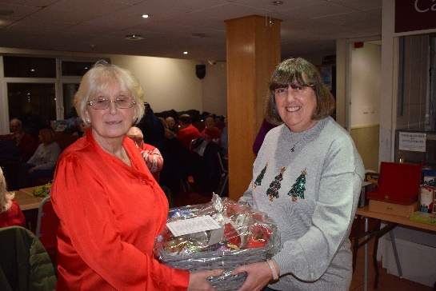
A really good evening with around 50 members attending. The special draw, which was for a Christmas Hamper made up of lots of Christmas goodies and the winning ticket drawn belonged to Karen Gleeson. The buffet was enjoyed by all and this was followed by the raffle which raised £140.00. Thanks go to Nick Palmer for doing the music and the staff of the CMC S&S Club.

SWIM SESSIONS
You will need to book your place if you are attending for the first time, after that you will be put on the list that you will be attending regularly. However, if you are not going to attend at a session, please can you let Pamela know.
HOWELLS SCHOOL sessions for January are on Sunday 8th, 15th, 22nd and 29th.

There is now only one session and that is from 6.15pm to 7.00pm.

For our beginners and novices, their session will be for half an hour from 5.45pm – 6.15pm.

CMCS&S Club - the sessions for January are on Thursday 5th, 12th, 19th and 26th.

MY 30 YEARS OF THE NEWSLETTER!
This year will be the start of the 30th year of me editing and producing the newsletter. I took over from Elaine back in 1993 with my first edition being the April / May issue. It was first typed out on an electric typewriter until I had a computer. I have still got most of the master copies of the early newsletters, although when I just kept copies on the computer, I lost some, however I now keep a paper copy on file. Over the years I have done different designs and layouts. I did like doing the booklet style but that was awkward when e-mailing it out especially if people wanted to print it out, so look out as I may change designs once or twice during the year. So, I hope you will all keep on reading this fine and informative publication.

TOTE & JUTE BAGS
We have a supply of Tote Bags and Jute Bags which have the Club Logo on the side which we are selling at £2.50 and £4.00 respectively. These will be available by contacting Pamela.

ANNUAL MEMBERSHIP
ALL members should, by now, have paid. If it has slipped your mind, please contact Barrie, details below.
Membership for 2022/2023 is £24.00 for the year. Any new members who join us during the year will pay a pro-rata rate.

BANK TRANSFERS
To avoid paying bank charges on cash and cheques when paying any monies to the Club please try and do it by bank transfer, the details are…
Bank: HSBC – Account name – Cardiff Chameleons – Sort Code 40-16-30 Account Number 01431285
It would also be helpful if you could add your surname and/or reason for payment e.g., Membership.
Many thanks for your help.

How to contact us
Coaches | Pamela – 029 2025 7314 / 07817 380355 pamela.bailey6@virginmedia.com
Coaches | Robin – 029 2021 6008
Coaches | Barrie – 029 2075 3038 / barriejenkins50@live.com
Treasurer | Barrie Jenkins – Details as above.
Newsletter  &  Chair | Steve – 029 2025 7314 / 07791 759360 /stephen.bailey497@ntlworld.com  33 Ty Cerrig, Pentwyn, Cardiff. CF23 7DP  Items for the newsletter to be in 5 days prior to the end of the month. Please put it as a Word attachment if on e-mail
Other contacts | Denise – 029 2075 2909 Ian – 029 2023 3065
Club sessions
Swimming - Howells School – Sunday 5.45 – 6.15pm (novices) and 6.15 – 7.00pm (First time booking required)
Cardiff Medical Centre Sports & Social Club (UHW site) – Thursday 8.00pm – 8.45pm (First time booking required)
Bowls – Cardiff Indoor Bowls Club - Friday 4.00 – 6.00pm

